

|  |  |
| --- | --- |
|  |  |
| Student Name: | Aagam Sanjay Shah |
| Deliverable: | In-Class Tasks Week 5 Assignment |
| Course Name: | [NTWK8141-24S-Sec3-Linux Serv](https://conestoga.desire2learn.com/d2l/home/1124154)er |
|  |  |
| Date Assigned: | 05/06/2024 |
| Date Due: | 06/06/2024 |
| Rules: | * Individual. * Cheating is not allowed. * Plagiarism counts as cheating! * That FAILURE to submit work in the course can result in a grade of ‘F’ or ‘I’ for failure to complete the course! |

**Real World Scenario 1**

**CREATING AND MODIFYING A FILE WITH THE NANO TEXT EDITOR**

1. Log into a Linux system using the sysadmin account and the password you created for it.

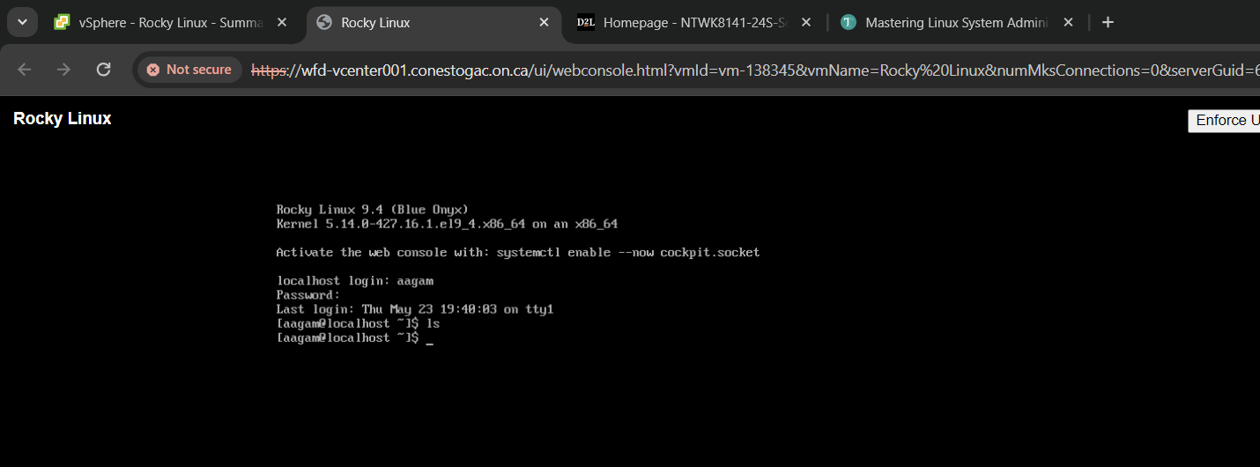

1. Create a new text file with nano by typing **nano QuestAns.txt** and pressing the Enter key.

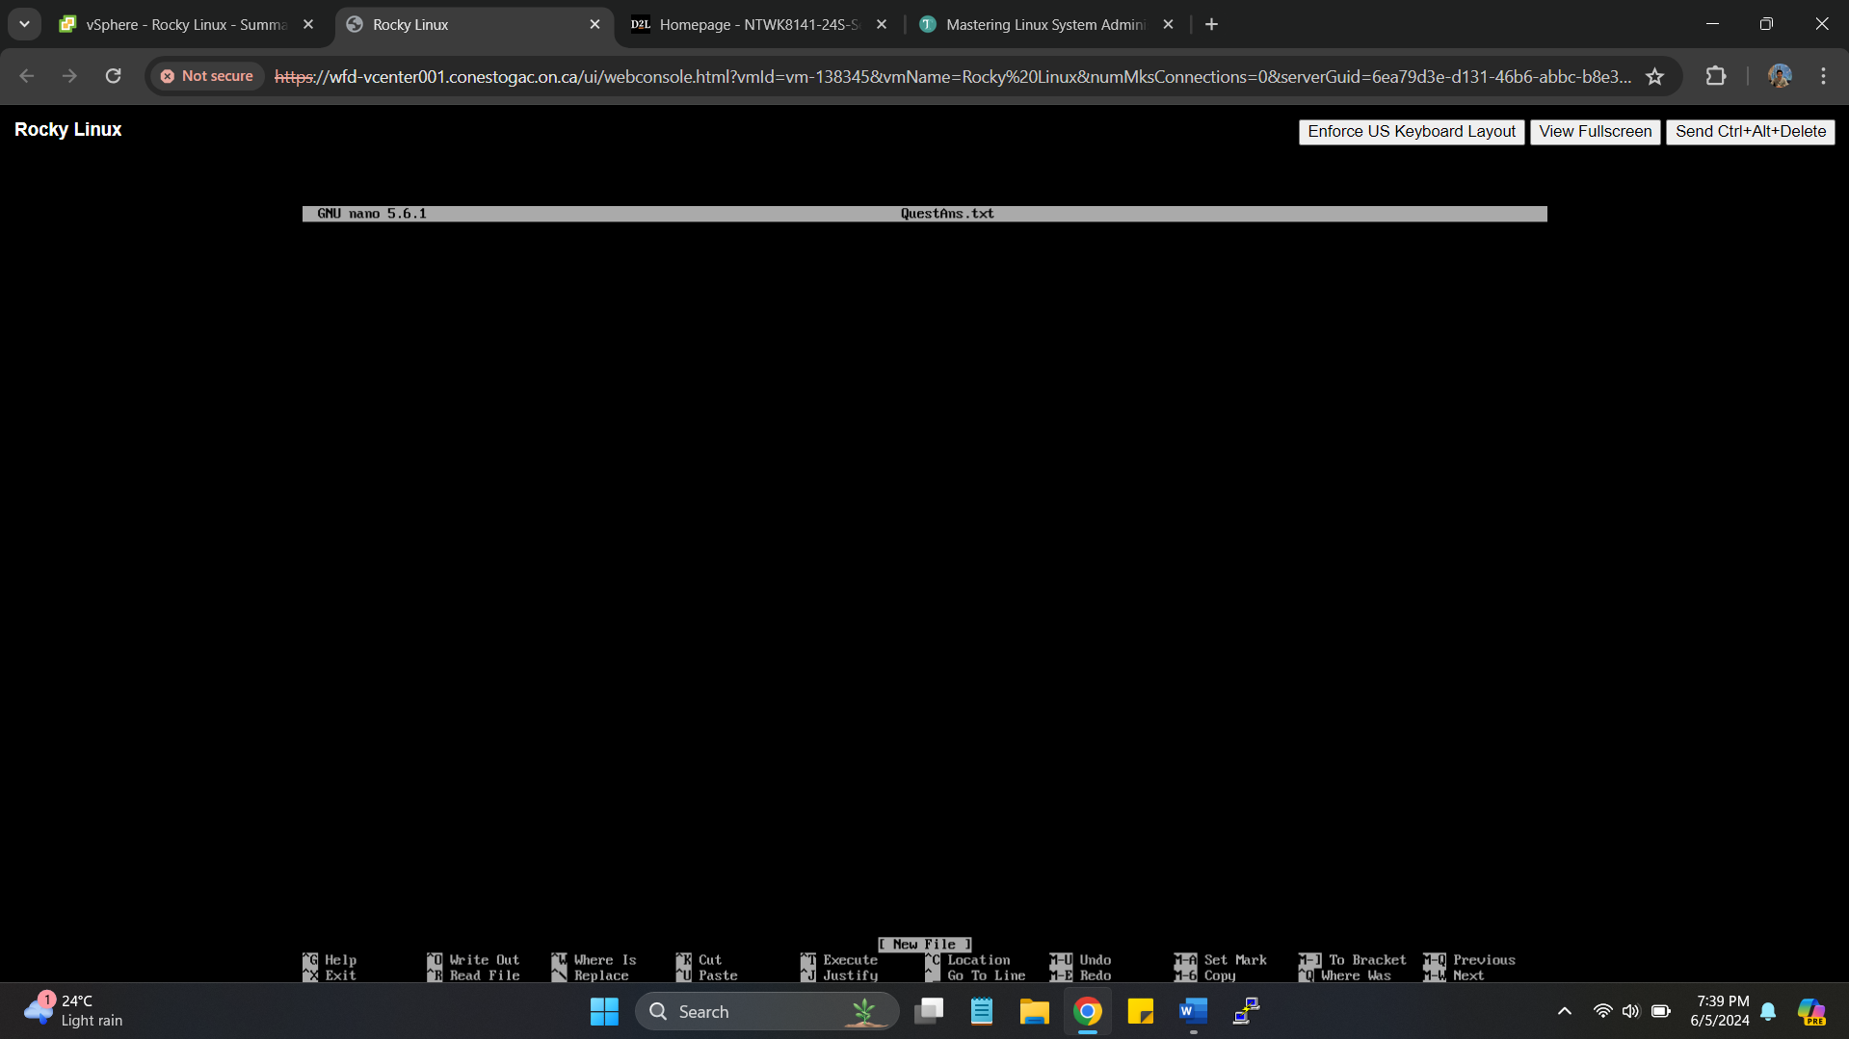

1. From “The Bottom Line” section of this chapter, type in the text for the “Master It” paragraph concerning the vim editor and then the text in the “Master It” paragraph for the nano editor.

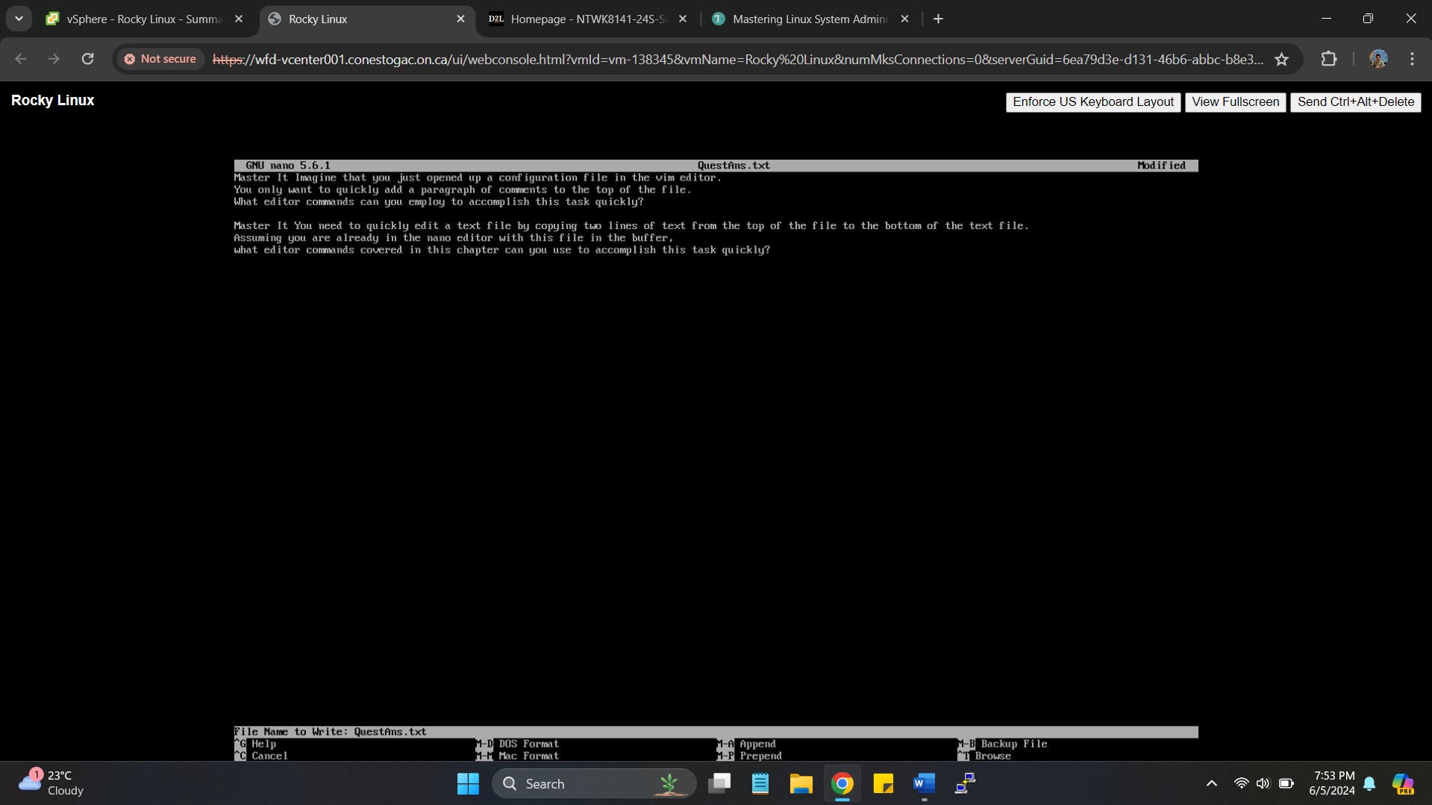

1. Save the file by pressing the Ctrl+O key combination, and then press Enter when the editor asks you the file's name.



1. Exit the editor by pressing the Ctrl+X key combination.

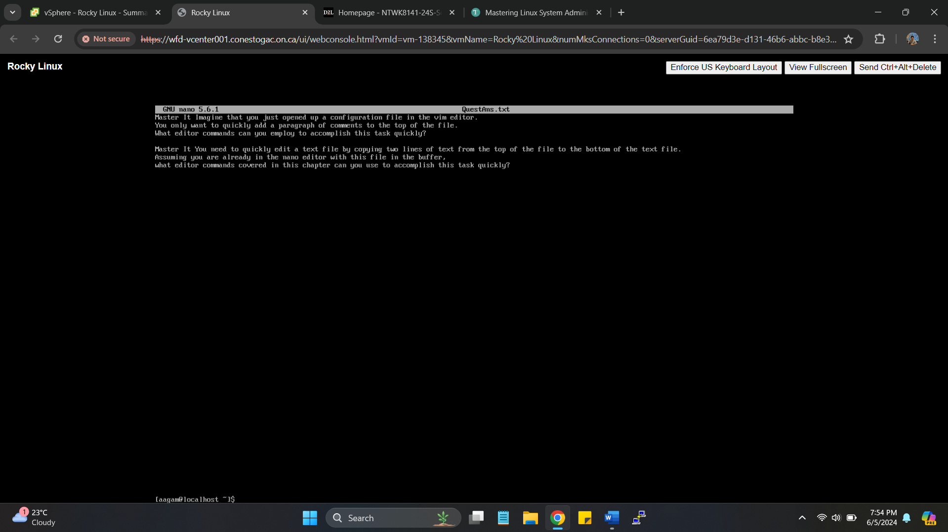

1. Determine the solutions for both the “Master It” questions before you return to modify the **QuestAns.txt** text file.

Solution 1: To go on the top press gg, to insert comments press O, type comments, to exit insert mode press Esc and :wq to save and exit the file.

Solution 2: To cut the top two lines, press Ctrl-K, TO go to the bottom of the file, to paste the lines, user Ctrl-U

1. Return to edit the text file by typing **nano QuestAns.txt** and pressing the Enter key.

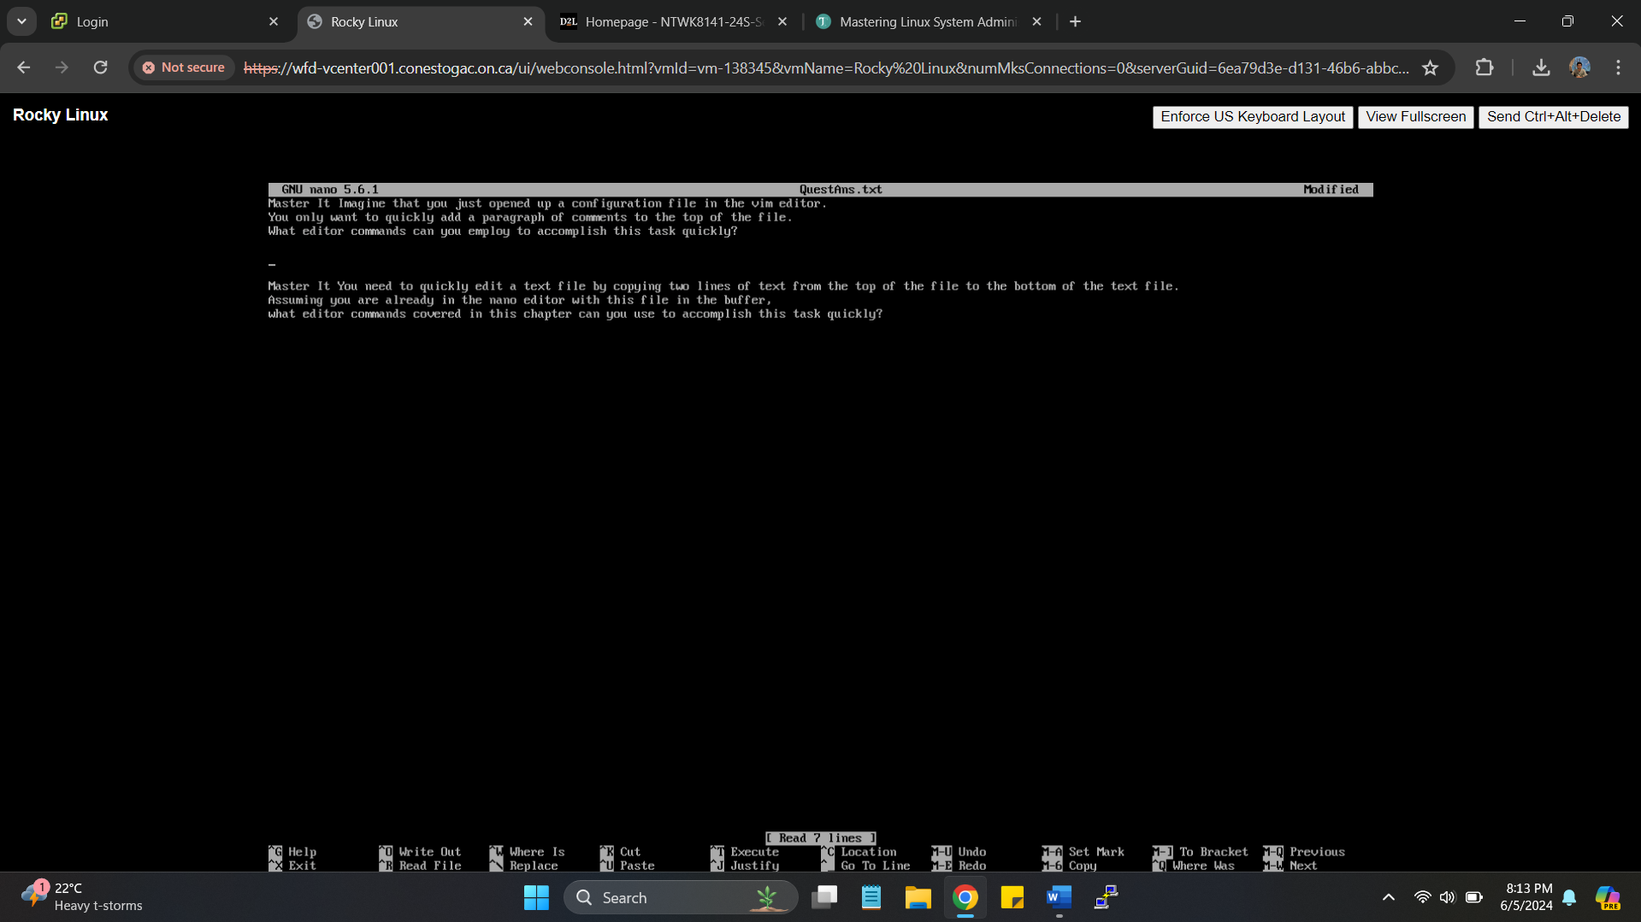

1. Add each solution under its appropriate “Master It” paragraph in the text file. Try to use as many key combinations in [Table 8.3](https://texidiumbrowserbooks.blob.core.windows.net/00017598/OEBPS/Text/c08.xhtml#c08-tbl-0003) for movement through the editor as possible.

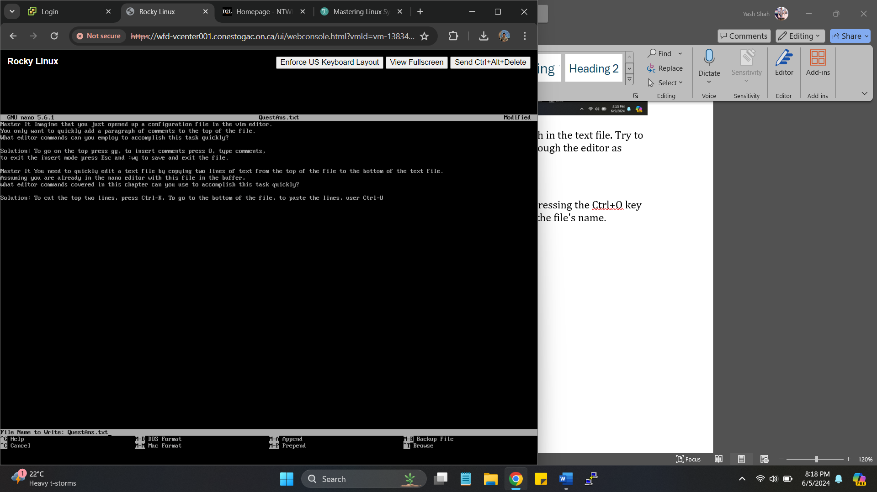

1. When you are finished adding the solutions, save the file by pressing the Ctrl+O key combination, and then press Enter when the editor asks you the file's name.

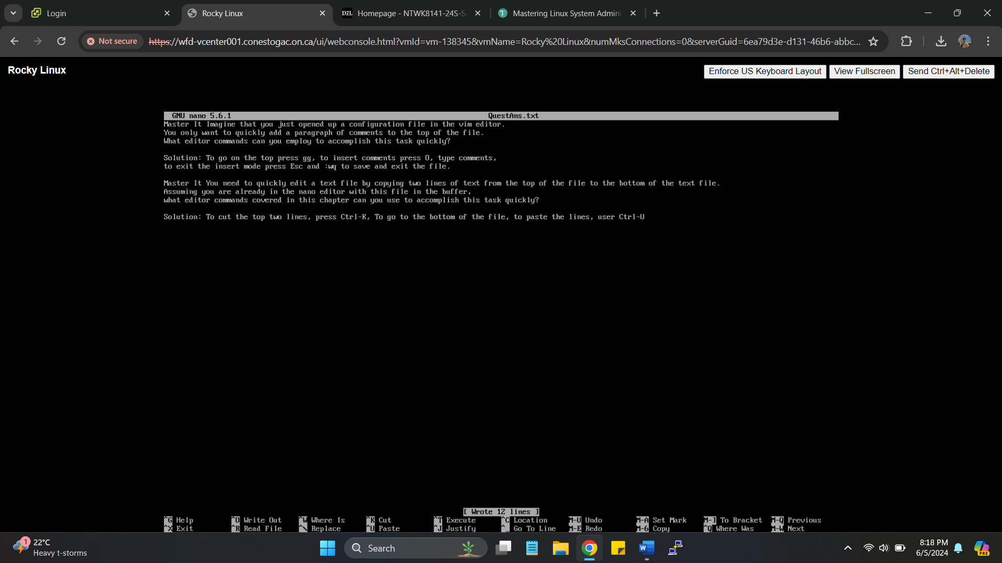

1. Exit the editor by pressing the Ctrl+X key combination.

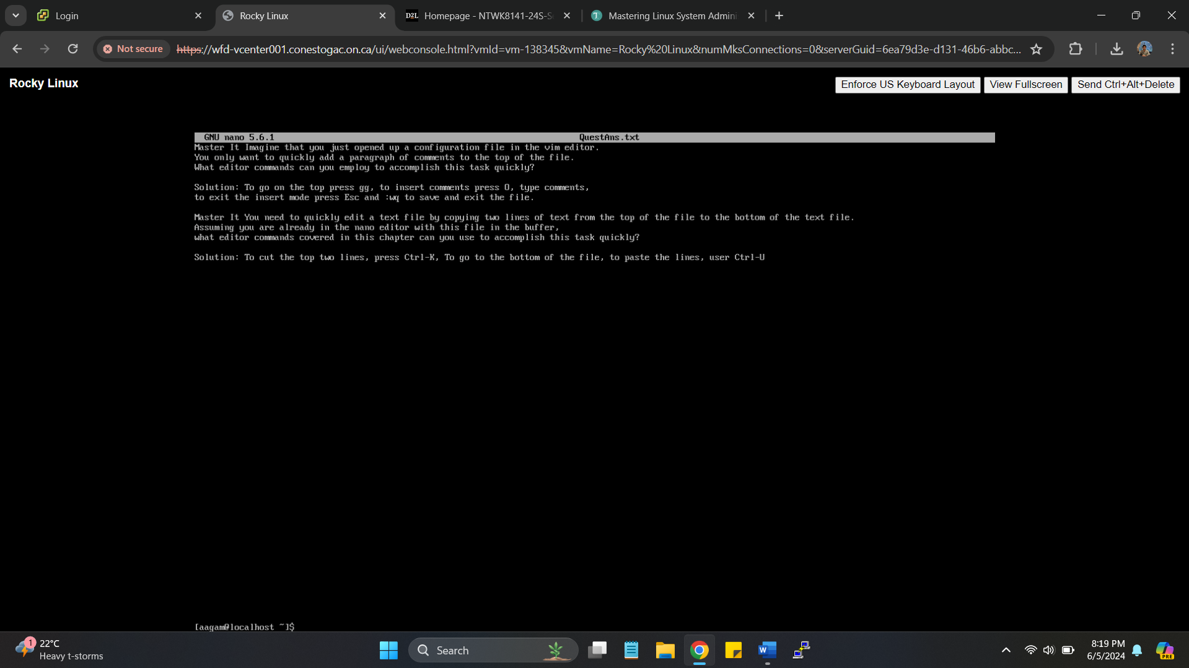

**Real World Scenario 2**

**TRYING THE TAR COMMAND**

The following steps will take you through trying out the archiving and restoring files:

1. Log into a Linux system using the sysadmin account and the password you created for it.

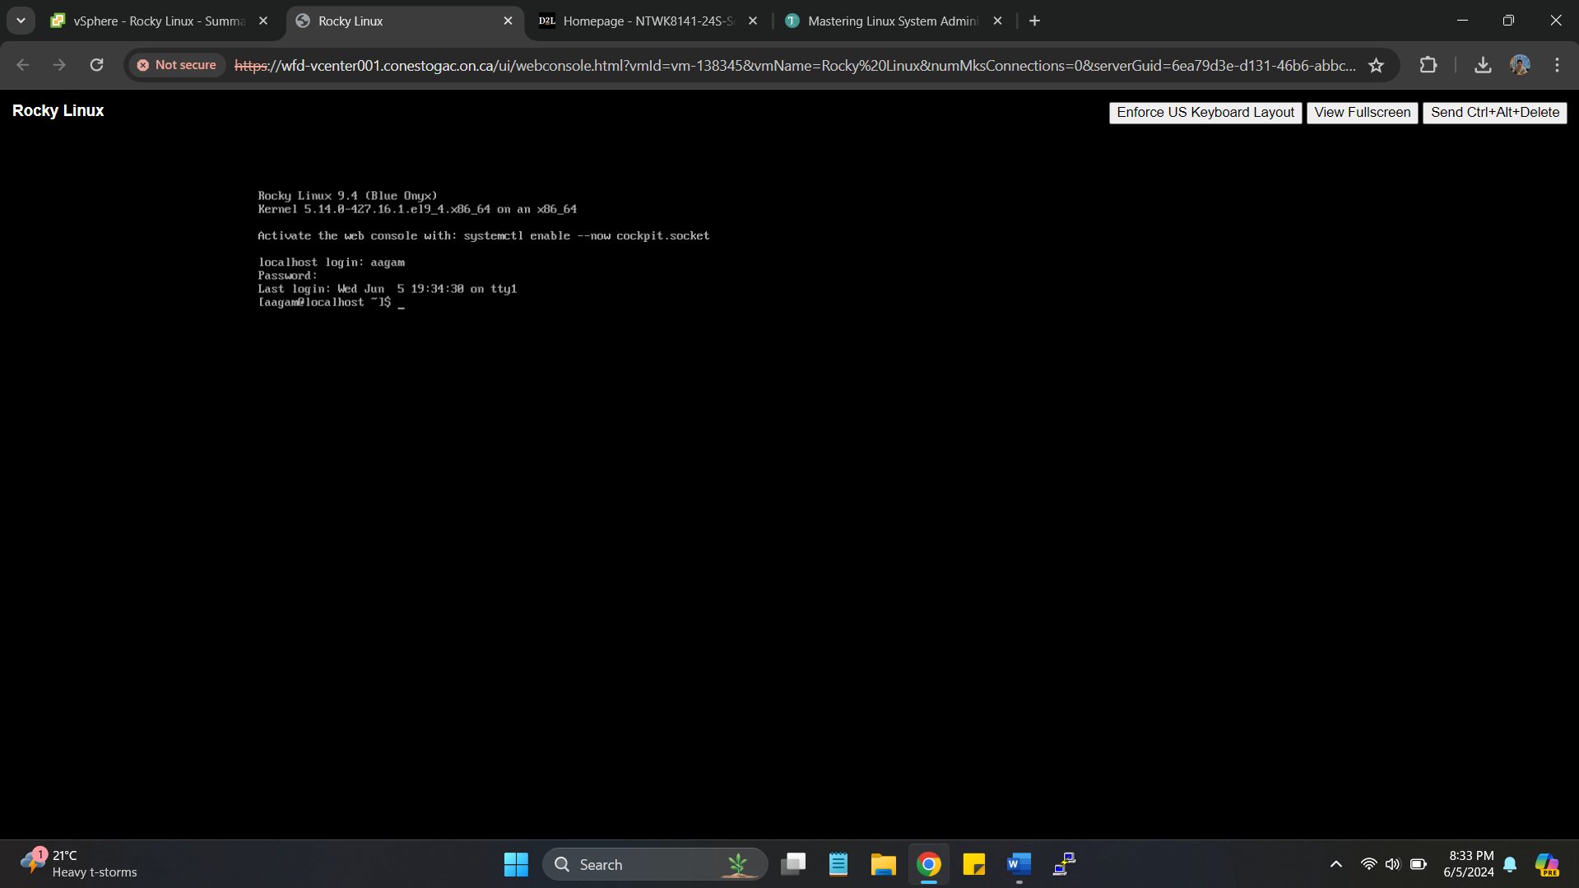

1. Copy the /etc/passwd file to use for backup practice by typing **cp /etc/passwd $HOME/passwd1.txt** and pressing Enter.

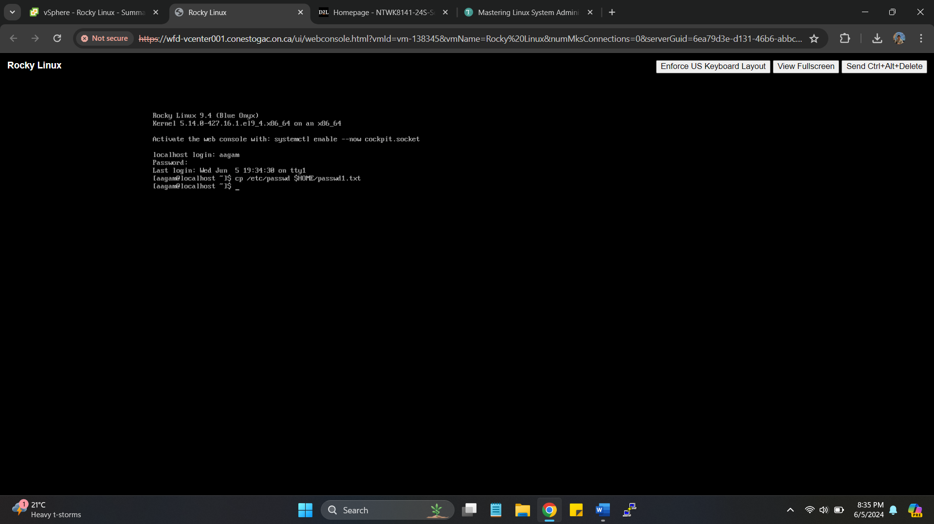

1. Do this again to make a second file by typing **cp /etc/passwd $HOME/passwd2.txt** and pressing Enter.

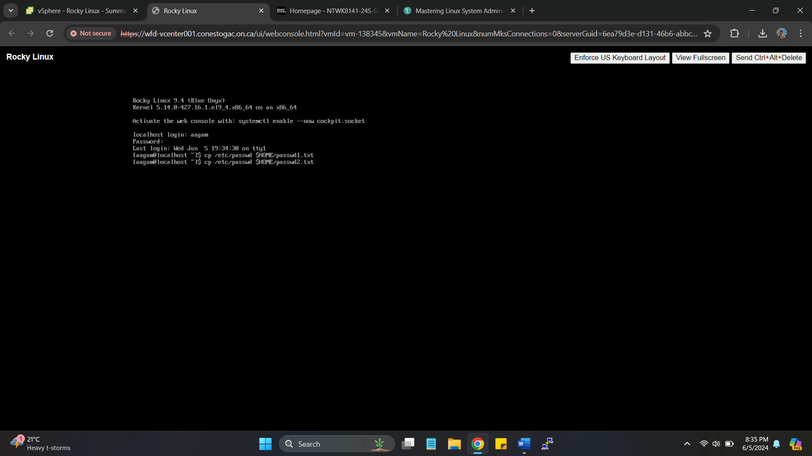

1. You need one more file, so type **cp /etc/passwd $HOME/passwd3.txt** and press Enter.

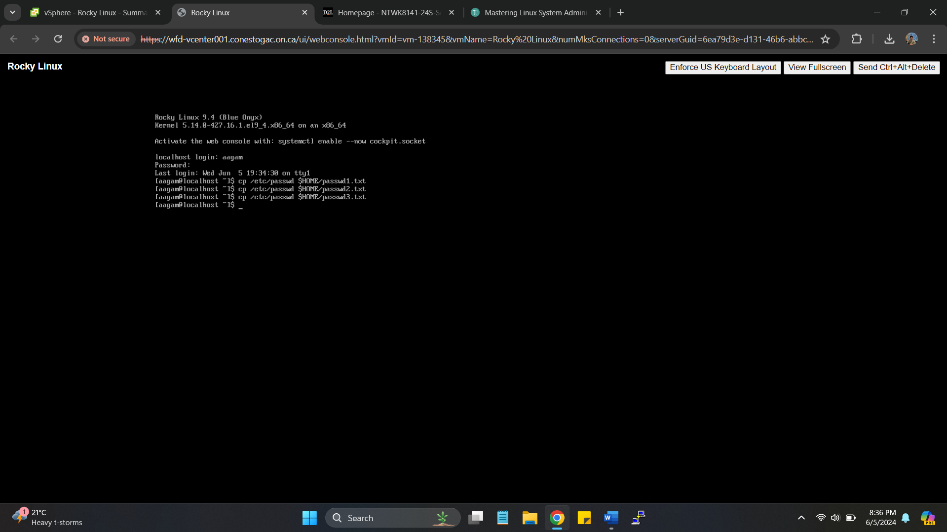

1. Check to ensure you have three password files by typing **ls passwd?.txt** and pressing Enter.

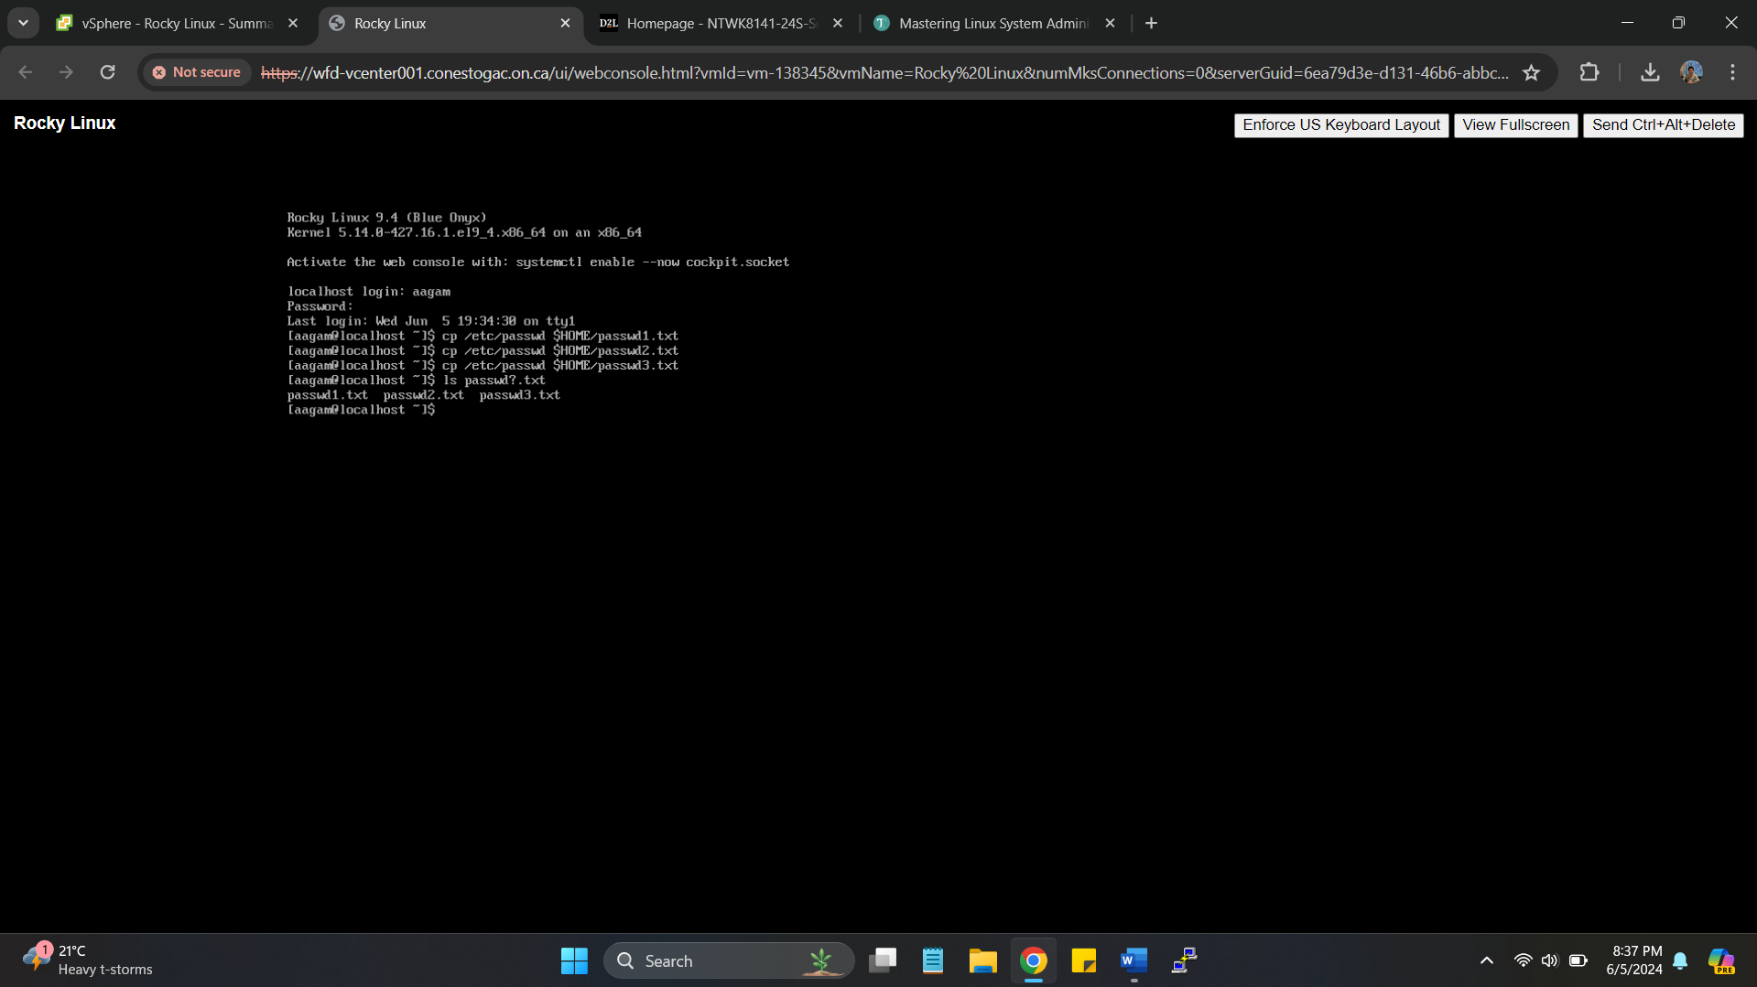

1. Now that you have some files to archive, use the tar utility to make a tarball. Type **tar ‐zcvf PArchive.tgz passwd?.txt** and press Enter. You should see the three files' names displayed as they are processed by the tar command.

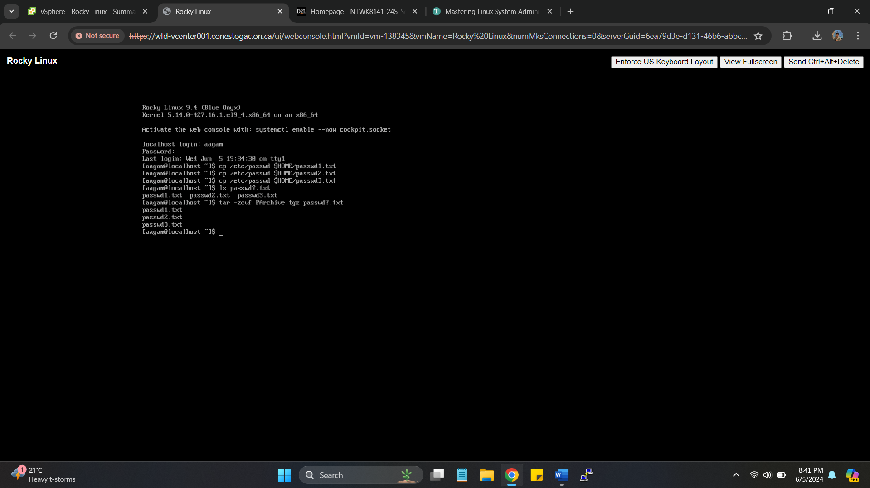

1. Review the PArchive.tgz tarball's contents by typing **tar ‐tf PArchive.tgz** and pressing Enter. You should see the three files' names that were displayed in the previous command.

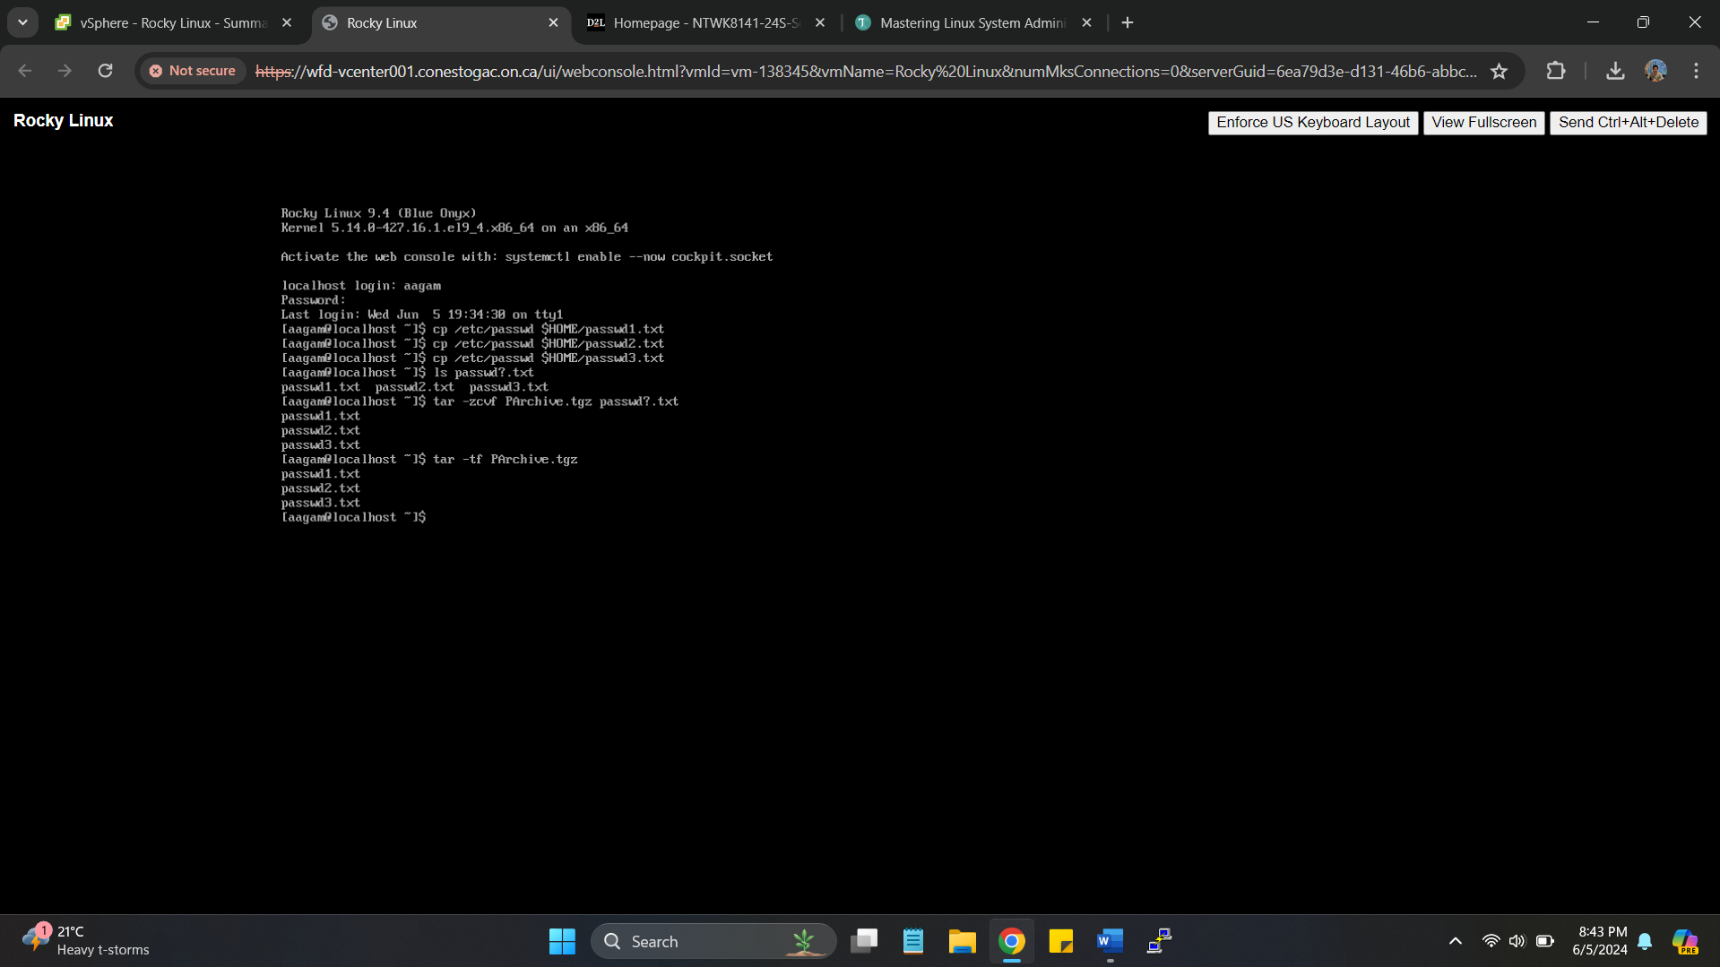

1. Before you decompress and extract the tarball's files, you'll need a place to put the files. Create a new directory in your present working directory by typing **mkdir PArchiveDir** and pressing Enter.

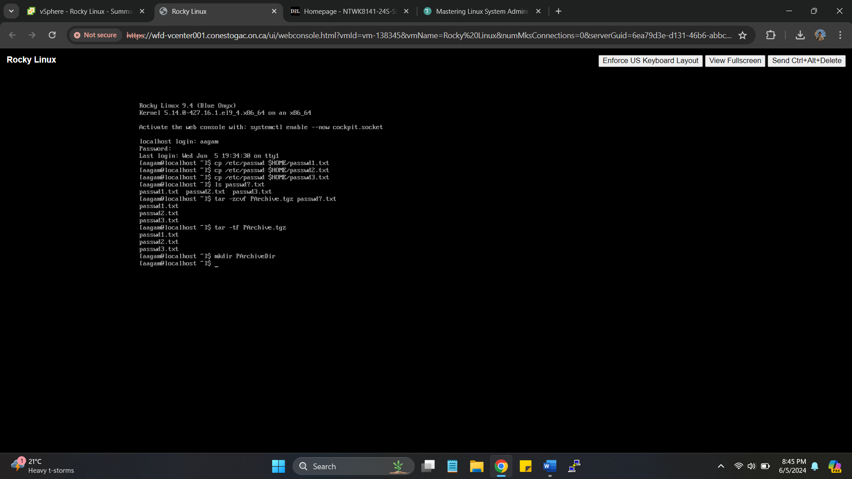

1. Copy the tarball file to the new subdirectory by typing **cp PArchive.tgz PArchiveDir/** and pressing Enter.

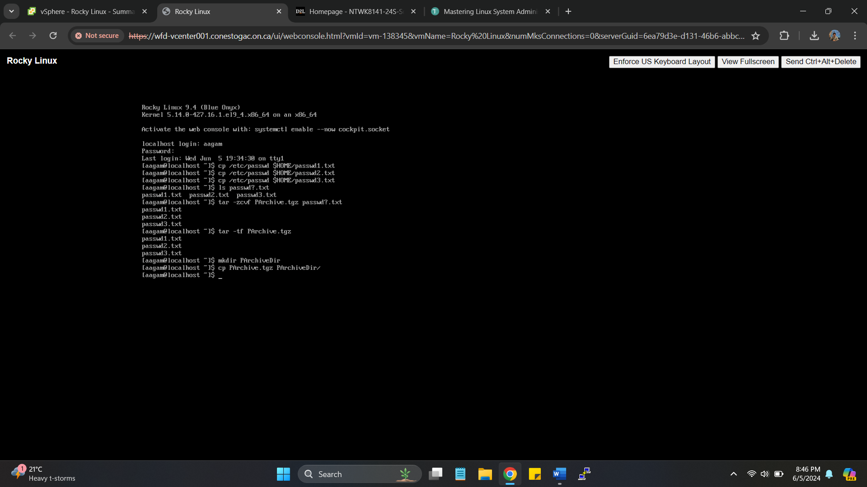

1. Move your current working directory into the new subdirectory. Type **cd PArchiveDir** and press Enter.

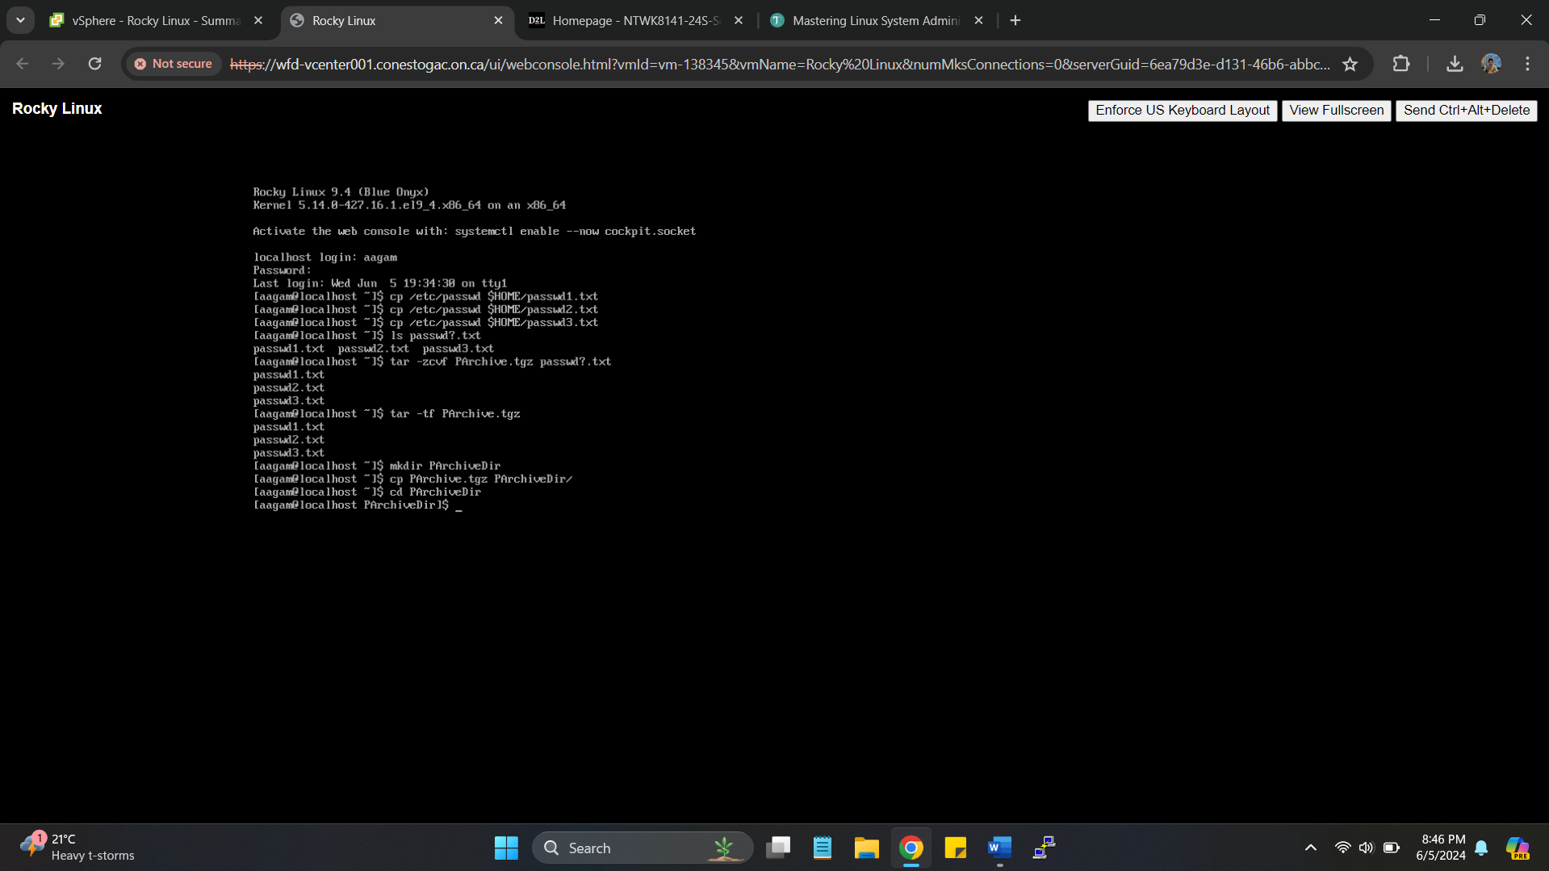

1. Double‐check that you are in the correct directory by typing **pwd** and pressing Enter. You should see something similar to /home/sysadmin/PArchiveDir displayed.

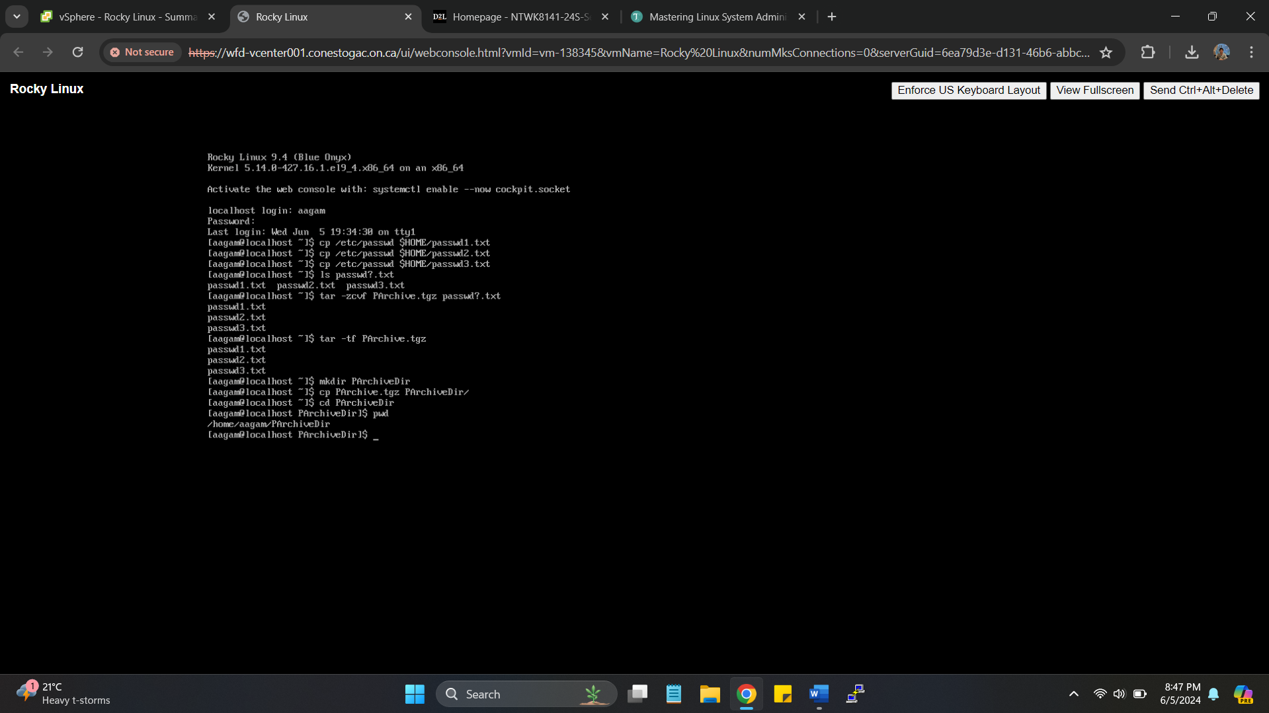

1. Now you can decompress and unpack the tarball in this subdirectory. Type **tar ‐zxvf PArchive.tgz** and press Enter. You should see three files' names displayed as they are processed by the tar command.

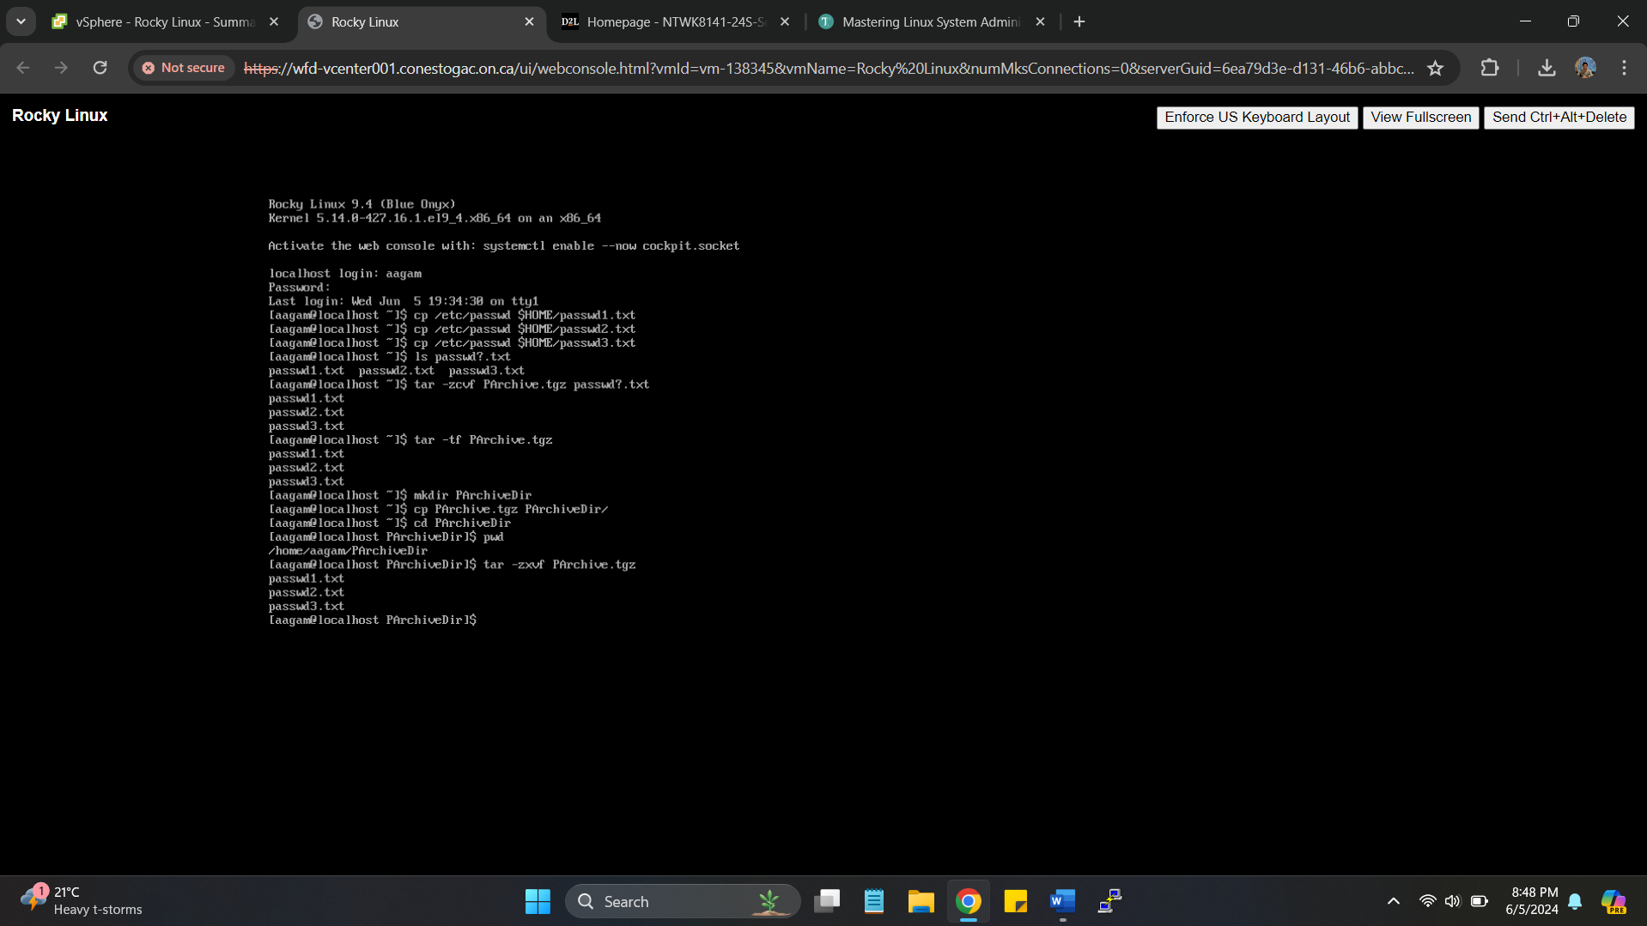

1. Double‐check that the files were extracted by typing **ls** and pressing Enter. Do you see the three password files as well as the PArchive.tgz file? You should.

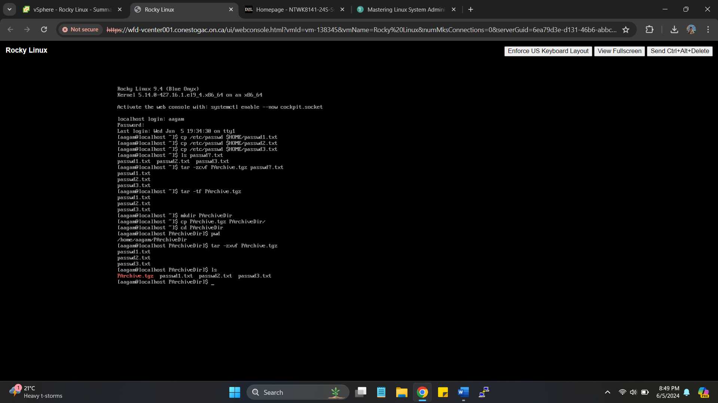

**Real World Scenario 3**

**VIEWING THE INSTALLED MODULES**

You can use the lsmod command to view the kernel modules currently installed on your Linux system. Just follow these steps:

1. If you've not done so already, log into your Linux system as a normal user account.

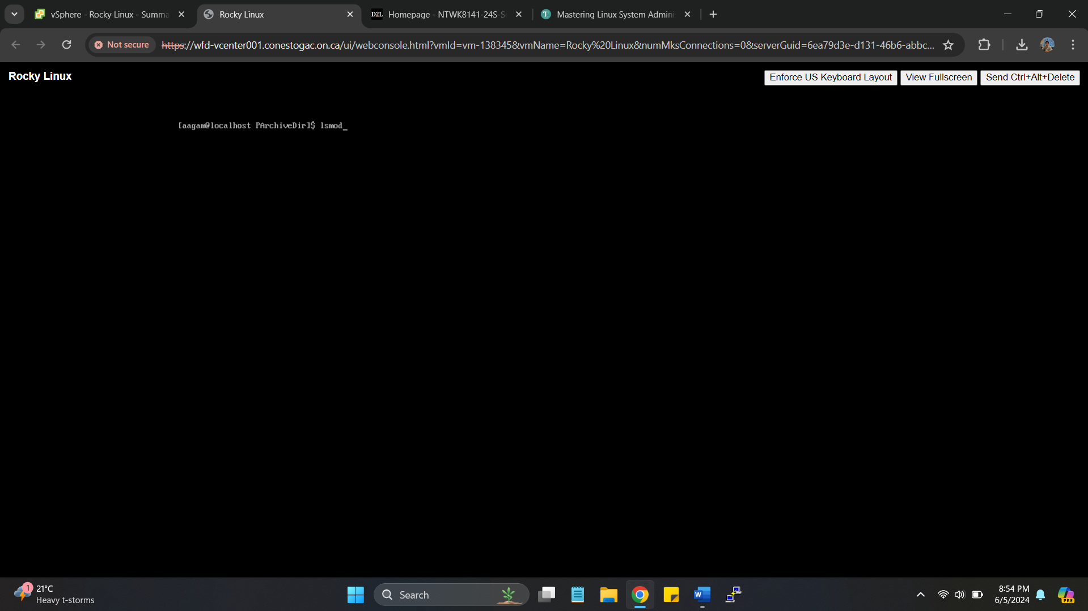

From the command prompt, type the command **lsmod**. You should see something similar to the following output:

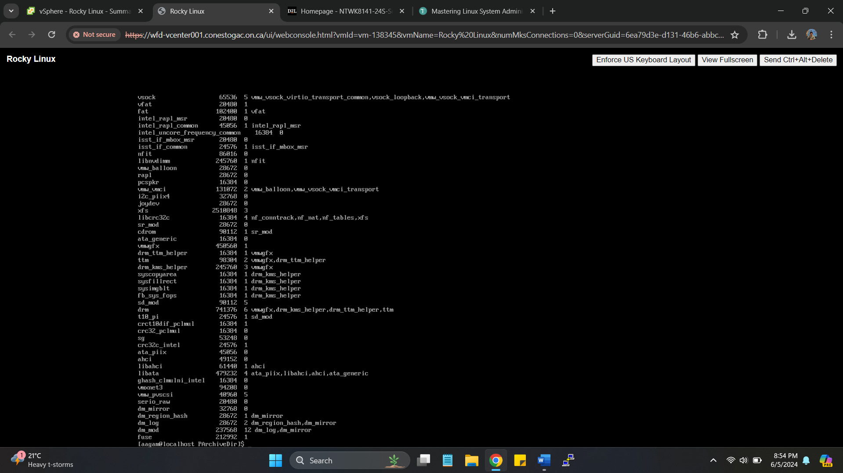

**Real World Scenario 4**

**ADDING A USB STORAGE DEVICE TO THE LINUX SYSTEM**

This exercise walks you through how to view the kernel messages and device entries that occur when you connect a USB storage device to the Linux system.

1. Log into your Linux graphical desktop and open a command prompt window.

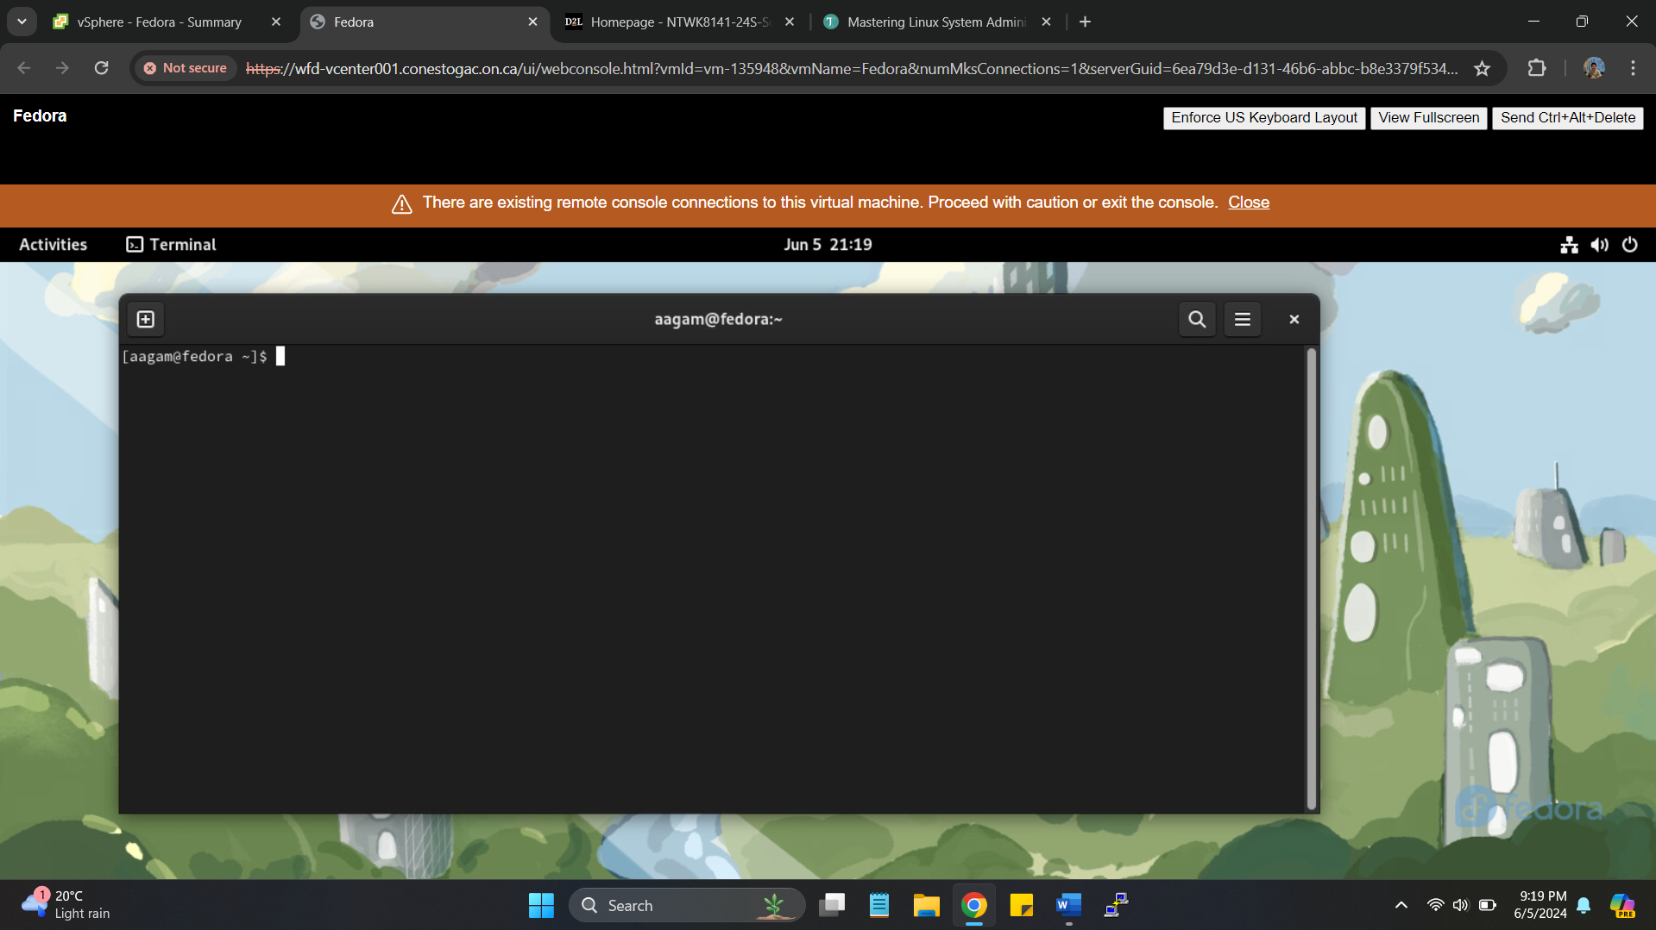

1. At the command prompt, enter the ***lsusb*** command to view any USB controllers and devices connected to your system. Using **lsblk**

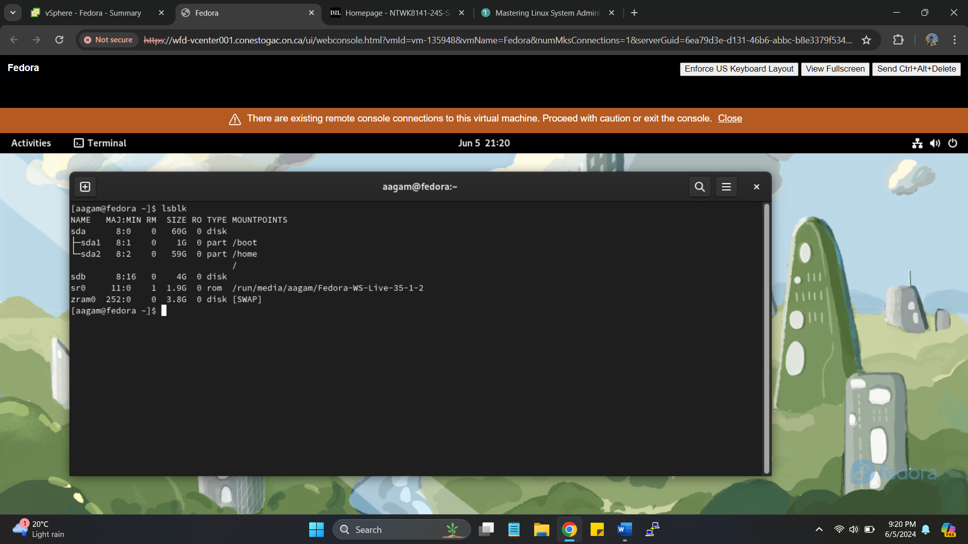

1. Plug a USB storage device, such as a memory stick, into a USB port, and then wait a minute or so for the kernel to detect it.

* Added Hard disk of 4 GB as USB port

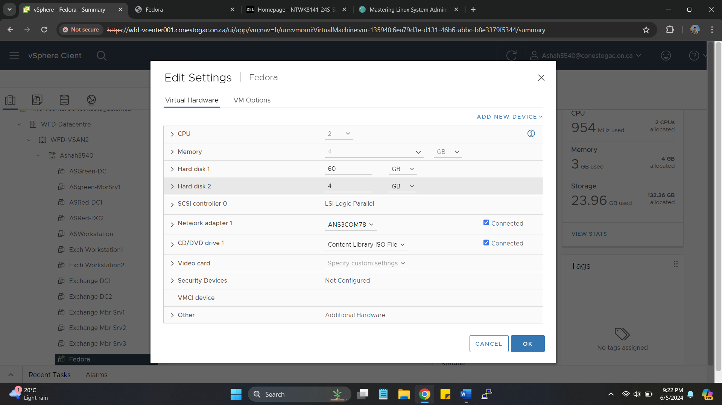

1. Type the command **dmesg**, and observe the kernel ring buffer entries entered when the kernel detected the new USB device. Note the device name assigned to the new device (such as sdb1).

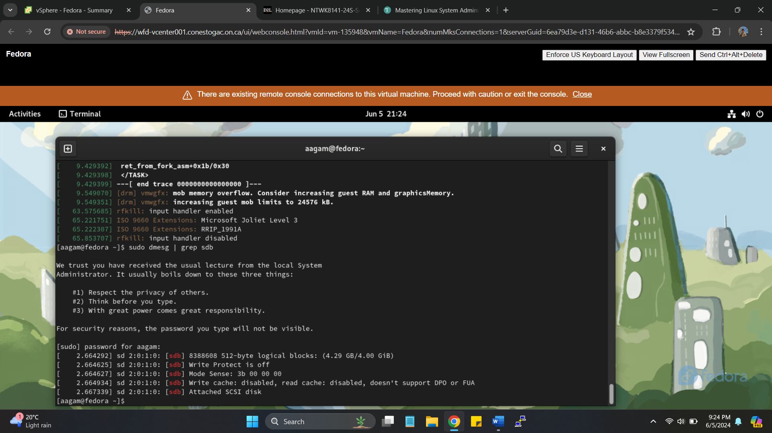

1. Type the **lsusb** command again and see if the new device appears in the output.

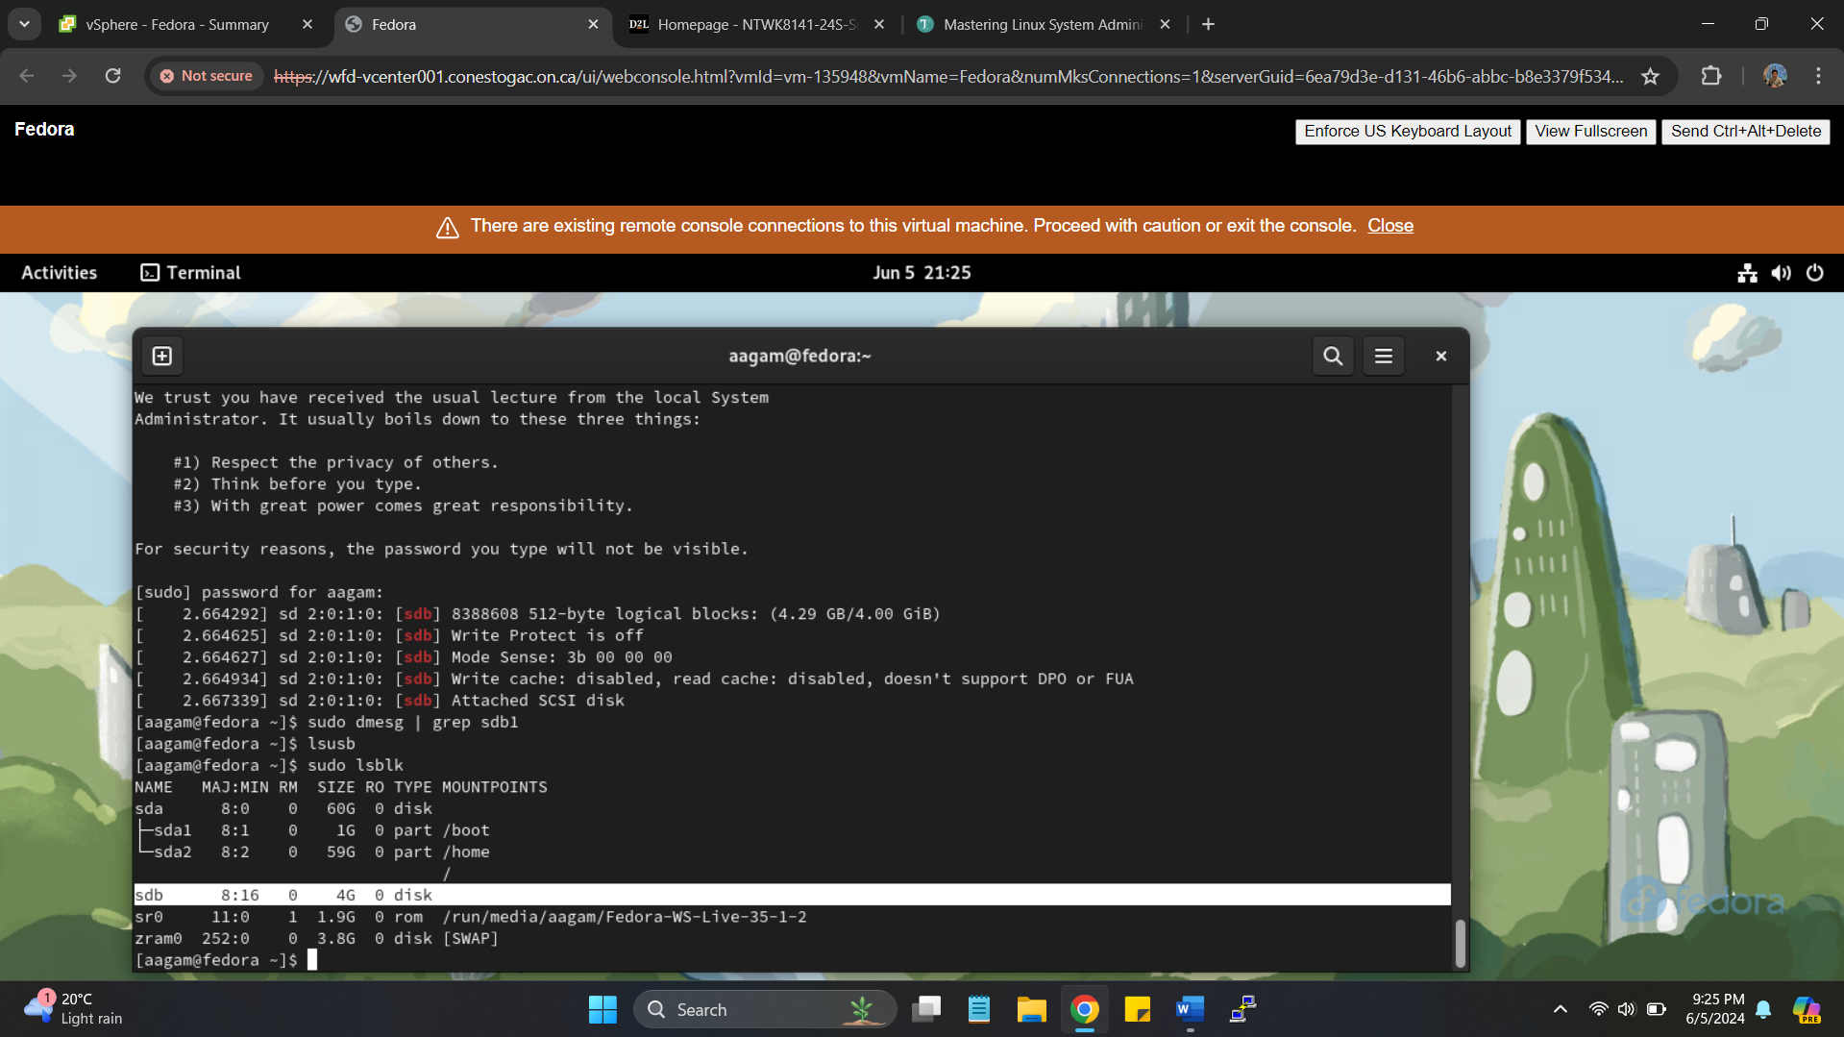

1. Type the command **ls /dev/sd\*** to view the SCSI devices on the system. You should see the USB device name that appeared in the dmesg output appear as a device file in the /dev folder.

